Financial Lit Name: _______________________

______________ _____________

WS Assessment

Target 19:

Income taxes

**I can:**

* Express tax schedule algebraically.
* Calculate federal income taxes using tax table and tax schedules
* Construct income tax graphs using compound equations

**Unit 9 Math Topics:**

* Cusps
* Piecewise functions
* Linear equations and inequalities
* Literal expressions
* Percent

Imagine how much money it takes to run your city, state, and federal governments. Where does the money come from for police forces, the space program, military defense and national security, health research, social programs, and other government programs? Taxpayers!

There are many different types of taxes. **Property taxes** are collected based on the value of the property you own. **Sales taxes** are collected based on the value of items you purchase. **Income taxes** are collected based on the amount of **taxable income** you earn. Your tax is the amount of money you must pay to the government. It is the price you pay to benefit from government services.

Federal taxes are collected by the **Internal Revenue Service (IRS)**. Although people don’t like to pay taxes, they are required and people realize taxes are necessary. You report your taxable income on a form called a **tax return**.

Your filing status is a description of your marital and family status on the last day of the year. You must indicate your fi ling status on your tax return. The choices for filing status are • Single • Married Filing Jointly • Married Filing Separately or • Head of Household

Google this tax table for stamp <https://www.irs.gov/pub/irs-pdf/i1040tt.pdf>

Go to IRS 2018 Tax table answer the following questions:

Ron is single. He is using an IRS tax form and calculates that his taxable income is $51,482. The instructions tell him to use the tax table to determine his taxes. How much does Ron owe in taxes?

Maria and Don are married Their combined taxable income is $153,900. Maria’s taxable income is $51,782.

If they are filing separately. How much does Maria owe in taxes? How much does Don owe in taxes? Show work

How much does they owe in taxes together (if filling separately)

How much does they owe in taxes together if filing jointly? Show work

Last year, Trinh paid $7,170 in income tax. What is his 2018 taxable income?

Determine the tax for each filing status and taxable income amount using 2018 IRS tax table

**a.** single $57,723 **b.** head of household $60,950

**c.** married filing jointly $63,999 **d.** married filing separately $57,521

2018 Tax table for the rich

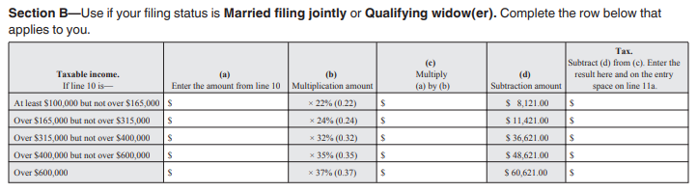Base on the given info, create a piecewise for tax function for married filing jointly, and graph. Stamp

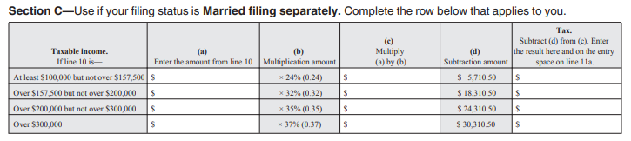

Base on the given info, create a piecewise for tax function for married filing separately, and graph. Stamp

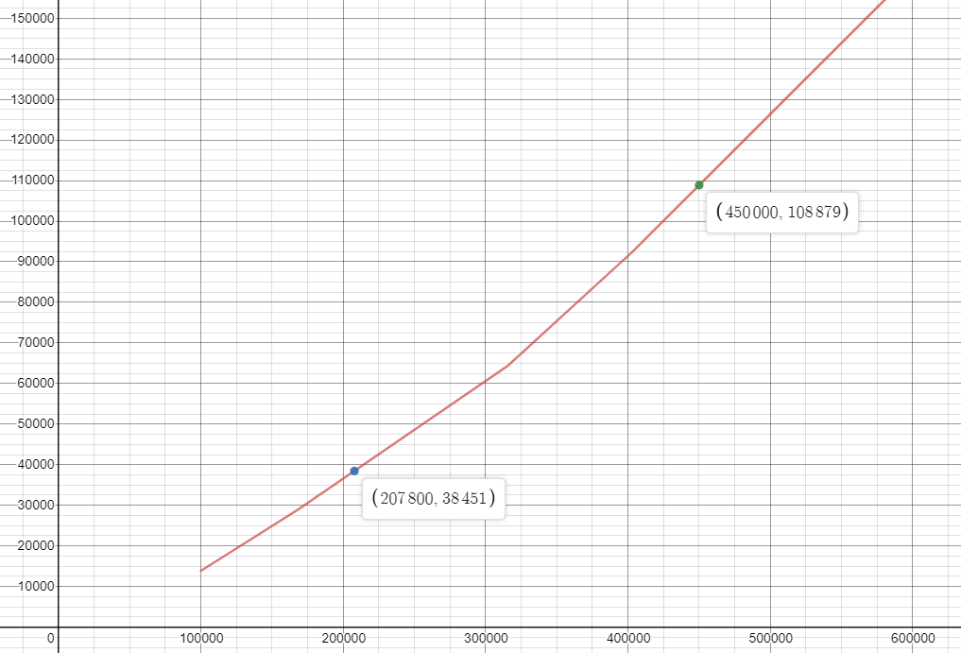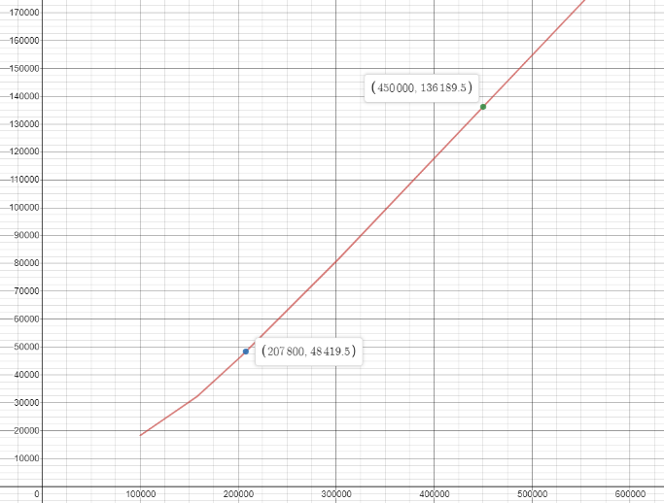Get stamp if your graphs same as below

Base on your graph, determine how much a PPS high school principal owe in tax for 2018? Google PPS salary schedule. _____________________

When you pay a sales tax, the tax percentage remains the same whether you purchase a $13 item or a $13,000 item. Sales tax is a **flat tax**, or a **proportional tax**. The tax rate does not depend on the cost of the item you purchase. Does the person with taxable income of $13,000 pay the same percent as the person who earns $13,000,000? Income tax does have different percentages on tax schedules. This is a

distinct feature of a **progressive tax system**.

If *f*(*x*) represents the entire tax function for married taxpayers filing jointly is written as below, explain progressive tax system in word



Express the equations in the married taxpayers fi ling jointly schedule above in *y* = *mx* + *b* form.

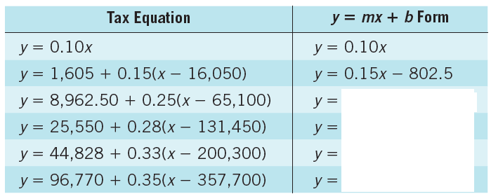

Write a piecewise tax function for the given graph. Stamp

What is the tax for an income of $30,000?

What is the approximate tax for an income of $99,000?

Base on the graph, Nick is paid every other week. He has $390 taken out of each paycheck for federal taxes. What is his taxable income?



**Assessment Target 19**

**I can…** Calculate federal income taxes using tax table and tax schedules

You are given this portion of a tax schedule from a previous year for single taxpayers with incomes over $71,950.



Write and graph a piecewise function of this tax in the form of y = mx + b. Stamp

Create an associated tax computation spreadsheet for the tax schedule using the linear equations you have identified. A template for the worksheet is shown below. Stamp



Use the tax table to figure the tax own for a person who makes. Stamp

$100,000 by desmos ________________ by worksheet _____________

$200,000

$400,000